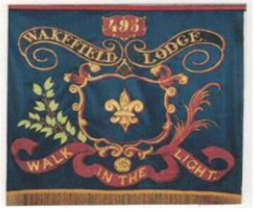

The Wakefield Lodge no. 495
Date of warrant 1st MARCH 1844

Lodge Profile Document

No. 495 on the Register of Lodges of the United Grand Lodge of England
Province of Yorkshire West Riding
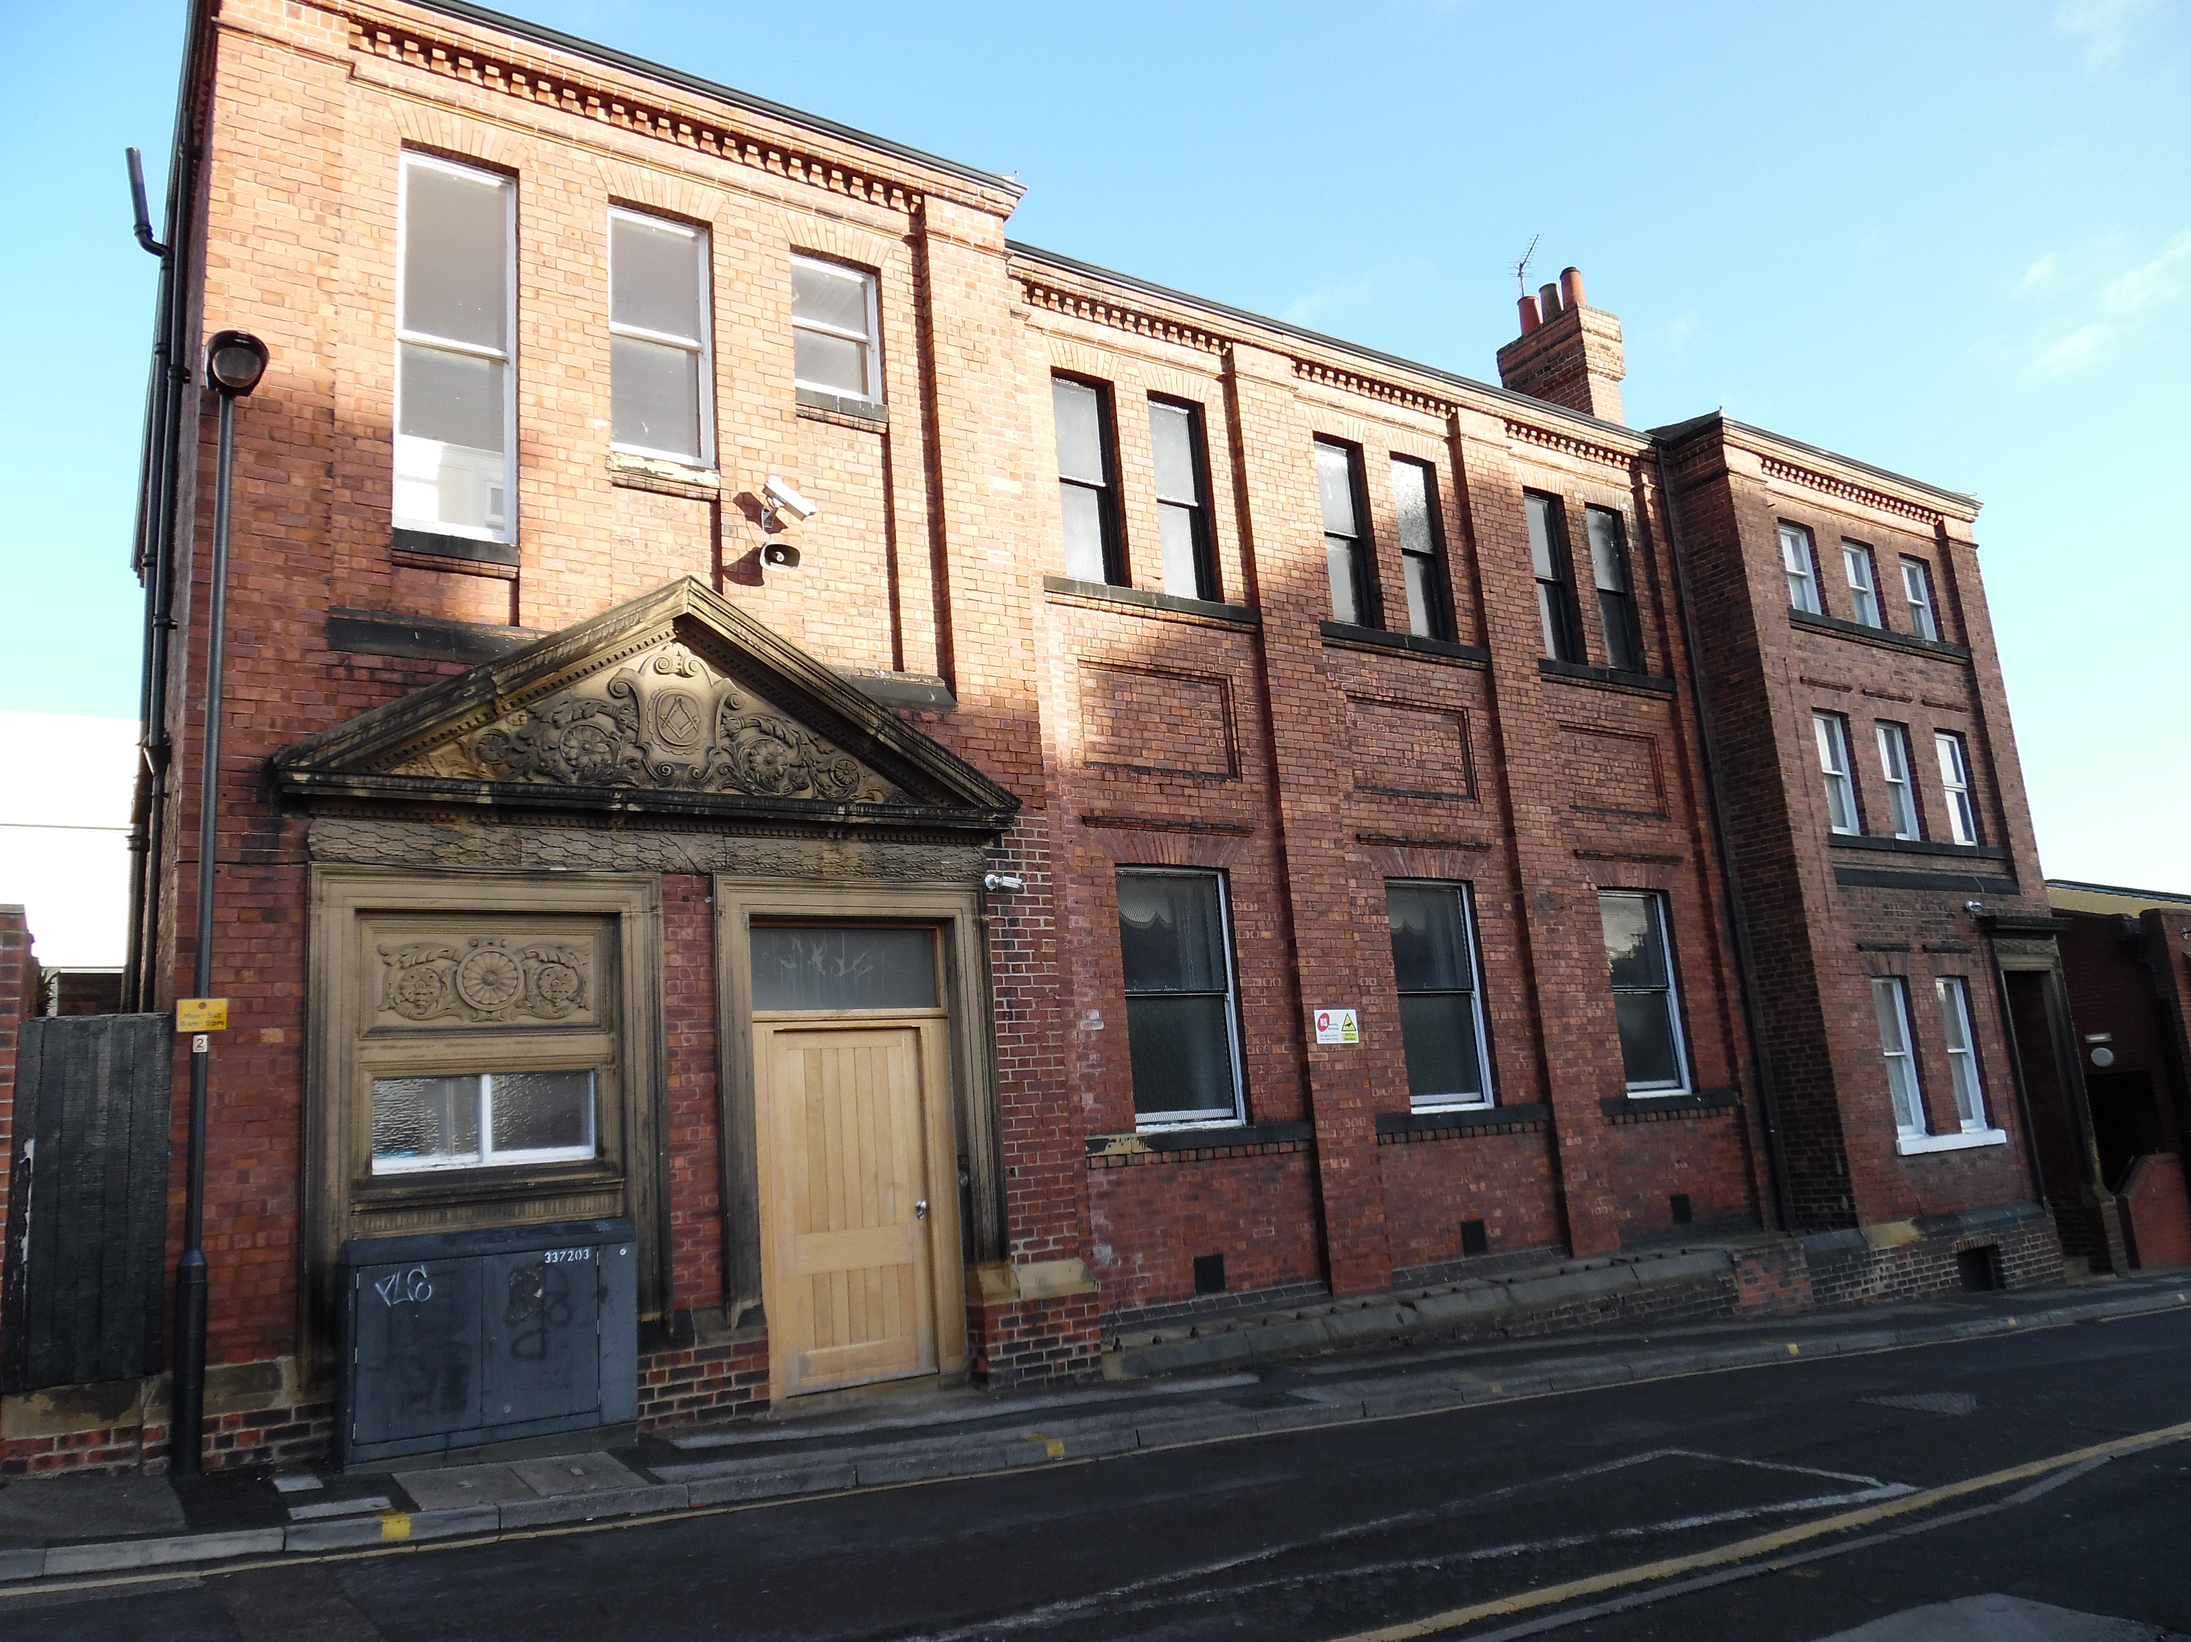
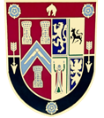
THE MASONIC HALL
ZETLAND STREET
WAKEFIELD
WEST YORKSHIRE
WF1 1QT

History of the Lodge and its membership
In February 1844, twelve Freemasons and were businessmen in the Wakefield area, submitted a petition to form a Masonic Lodge in Wakefield, most of these members were associated with the thriving Market in the Town. The first meeting of the Lodge took place on the 10th of April 1844 on Thornhll Street.
On 14th September 1853 the Lodge moved to the ‘Old Rectory House’ on what became Zetland Street, named in honour of the 2nd Earl of Zetland, who was at the time the Grand Master of the United Grand lodge of England. This became the City’s Masonic Hall and is still enjoyed by the Freemasons of Wakefield. Notably, several roads near the premises are named after prominent citizens involved in the Wakefield Market and who where members of the Lodge. Continuous and uninterrupted meetings have taken place there ever since.
Today, we have members from various walks of life, legal professionals, academics, scientists, Engineers, Retired emergency Services, and Naval Officers to name but a few.

Our Meetings
Our “Regular Meetings”, where we admit and advance members, and change our Officers for the year, are held at the Masonic Hall Zetland Street, Wakefield. WF1 1QT on the Second Tuesday of the months of September, through to May, inclusively, starting at 6.30 pm. We then dine at 8.00 pm, with the evening finishing at about 10.00 pm. The dress code is dark suit (or morning suit), white collar, tie (plain black, or Masonic tie), black shoes. On other Tuesdays throughout this period there is an informal get-together to practice certain parts of the meeting and have a discussion over a drink. We try to get together socially at other times during the year involving our partners.

Costs
The annual membership fee is £225, payable at the start of each year. As well as covering the running costs of the Lodge it includes the annual membership fee of the United Grand Lodge of England, the Provincial Grand Lodge of Yorkshire West Riding, and the Masonic Hall. As a paid-up Lodge member, you can attend meetings of other Lodges for no extra fee (apart from dining). We have a three-course meal after each of our “Regular Meetings”, costing £13. There is also a one-off fee for becoming a member of the Lodge, which is in the order of £130 which covers administration costs. Discounts can be applied to some of these fees for members under the age of 25.
Charity is important to Freemasons, and we are invited to make donations to Masonic and non-Masonic causes. How much you donate is between you and your own personal circumstances. There is no minimum or maximum level of donation.

Membership - who are we looking for?
We welcome enquiries for membership from members of our community who would be
able to participate regularly and share our values of integrity​ , ​ friendship​ , ​ respect​ , and ​ charity​ .​ The general requirements for those seeking membership under the United Grand Lodge of England are:
- Male; There exist Masonic Lodges that admit women (see Other Masonic Orders​ ​, below)
- A belief in a Supreme Being. This may be through membership or alignment with one of the mainstream religions of the world, a personal spiritual belief, or that the laws of science and nature equate with a Supreme Being. You will not be asked to explain or justify your belief, but when the name of God or the Great Architect of the Universe is invoked, this should mean something to you.
- At least 18 years of age. However our Lodge would suit a more mature man due to the demographic of our lodge, 40 to 60 year old, ideally from a professional or public service background.
- Have no criminal convictions. New members of the Lodge should be worthy of our trust and friendship and should treat all people with integrity, humility, and respect. Minor spent offenses will need to be disclosed.
What promises are made?
As a Freemason you are accepted into a community that prides “honour and virtue above the external advantages of rank and fortune” and so other Freemasons will see you as being friendly and trustworthy. As you may wish to attend meetings or gatherings where you are not known, there are ways of proving that you are a Freemason. When you become a member you are asked to declare that:
- You voluntarily seek membership and for honest reasons.
- You seek membership because you agree with its principles and a desire to improve yourself.
- You agree that you will act and abide by the principles and traditions of Freemasonry.
- You will not disclose anything to a non-member that you have been asked not to.

What will I get from membership?
People join for many different reasons. For most, it is an opportunity to meet with like-minded individuals. It is a chance to be part of a team and to develop skills, such as leadership, administration, and public speaking. It is an opportunity to expand your social life and make new friendships with those whose lives would otherwise have never crossed paths with your own. It is a chance to become involved in your community and act charitably. You will become a member of a worldwide organisation with a long history in continuing traditional values.
How do I join?
Just ask! Nobody is invited to join, so don’t wait to be asked. Ask to meet with us, chat online, or come along to one of our social events. Ask questions. If you decide that you would like to join we will ask you to complete an application form. Your membership will be proposed at a Regular Meeting and will ballot (vote) at the one that follows. If the ballot is successful, you can join and be initiated at that meeting or at another one within 1 year. If you were to ask any of our members if they regret anything about their membership, they are likely to say that they wish that they had joined sooner!
Other types of Freemasonry
There are other Masonic Orders that extend the experience of Freemasonry and whose membership is drawn from those who are Freemasons under the United Grand Lodge of England.
There are likewise other Masonic Orders that exist independently of the United Grand Lodge of England and these include those that admit only women (The Order of Women Freemasons and the Honourable Fraternity of Ancient Freemasons) or both men and women (Le Droit Humane: International Order of Freemasonry for Men and Women). All these forms of Freemasonry happily co-exist, and we sometimes work together on certain initiatives, but we cannot attend each other’s Lodge meetings.

Useful links

https://wakefield495-freemason.webador.co.uk/
https://www.ugle.org.uk/
https://www.wrprovince.org.uk/

Social Media
https://www.facebook.com/wakefieldlodge/
https://www.instagram.com/p/B5nvtqjFZHg/

